SIMATS ENGINEERING (SAVEETHA SCHOOL OF ENGINEERING)
Department of Artificial Intelligence and Data Science

ASSESSMENT TOOL 3 – ERROR ANALYSIS

Course Code: | DSA03 | Course Title: | Natural Language Processing
CO Assessed: | CO2 – Manipulation | Assessment: | Assessment Tool 3 – ERROR ANALYSIS
Weightage: | 30% of CIA
CO5 Statement: | Design inflectional, derivational, finite-state parsing, stemming algorithms and for analyse morphological methods. (BL-3)
Student Name: | I. Leela Sravan Kumar | Reg. No.: | 192425272
Section / Batch: |  | Date:

Code of Conduct
I I. Leela Sravan Kumar (192425272) (Name / Reg No) certify that this submission is my original work and that I have adhered to the guidelines specified for this assessment. I understand that any violation of academic integrity rules will result in disciplinary action.
Signature of the Student: I. Leela Sravan Kumar

Instructions
- Read all questions carefully before attempting the answers.
- Answer any 4 questions (2 Scenario-Based & 2 Programming-Based). Each question carries equal marks.
- Show all intermediate steps, calculations, probability computations, tagging decisions, and justifications wherever applicable.
- Duration: 30 minutes.

Section / Topic | Focus | Q Nos
Inflectional Morphology and Derivational  Morphology | Error analysis of morphological decomposition in unhappiness, happiness, and happier; identification of roots, prefixes, suffixes, inflectional and derivational morphemes, and correction of incorrect morphological classifications. | Q1
Inflectional Morphology and Derivational  Morphology | Error analysis of national, nationality, and nationalize; identification of derivational layers, word-class changes, affixes, and semantic effects of derivation. | Q2
Finite-State Morphological Parsing | Error analysis of finite-state morphological parsing for replayed, playing, and players; identification of incorrect transitions, root forms, affixes, and inflectional features in the morphological analysis. | Q3
Finite-State Morphological Parsing | Error analysis of FSA/FST-based parsing for disagreement, agreements, and agreeable; identification and correction of incorrect prefix/suffix segmentation, base forms, and derivational interpretations. | Q4
Porter Stemmer and  Applications of  Stemming in NLP | Programming-based error analysis of a Porter Stemmer implementation for words such as connected, connection, connecting, and connectivity; identify stemming-rule errors and correct the implementation. | Q5
Porter Stemmer and  Applications of  Stemming in NLP | Programming-based error analysis of a morphological normalization program that processes studies, studied, studying, and study; identify incorrect stemming outputs and modify the code to produce consistent stems. | Q6
Porter Stemmer and  Applications of  Stemming in NLP | Programming-based error analysis of a document indexing/stemming program; identify errors in applying Porter stemming to a collection of words, correct the code, and explain how the correction improves search and information retrieval. | Q7

Annexure A – Error Analysis

Question 1 – Error Analysis of Derivational Morphology in Biomedical Text
A biomedical information-retrieval system performs morphological decomposition of words before indexing research articles. The system incorrectly analyzes the words:
- treatment
- treatable
- retreatment
- treated
- untreated
The system sometimes removes prefixes or suffixes that carry important morphological information, resulting in incorrect search matches.
Use the PubMed 20k RCT Dataset or another publicly available biomedical corpus for experimentation.
Tasks
- Identify words that produce incorrect morphological analyses.
- Decompose the selected words into prefixes, roots, and suffixes.
- Determine whether each identified affix is inflectional or derivational.
- Explain the root cause of the incorrect morphological analysis.
- Propose a corrected morphological-analysis strategy.
- Compare the original and corrected analyses.
- Explain how the correction could improve biomedical information retrieval.

Word | Prefix | Root | Suffix | Affix Type
treatment | – | treat | ment | Derivational
treatable | – | treat | able | Derivational
retreatment | re | treat | ment | Derivational
treated | – | treat | ed | Inflectional
untreated | un | treat | ed | Prefix: Derivational, Suffix: Inflectional

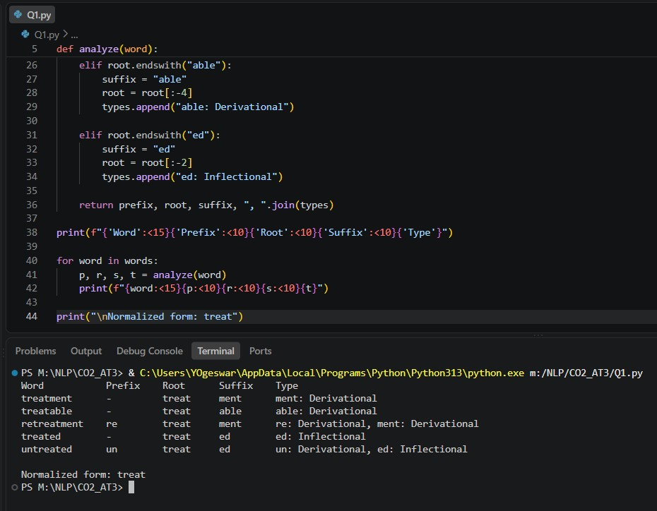
Question 2 – Error Analysis of Finite-State Morphological Parsing
A social-media NLP system uses a finite-state morphological parser to analyze user-generated text. The parser produces incorrect analyses for words such as:
- replayed
- unhappier
- disconnected
- players
- restarting
- unreadable
The parser can recognize a single affix correctly but fails when multiple prefixes and suffixes occur in the same word.
Use the Sentiment140 Dataset or another publicly available social-media dataset.
Tasks
- Identify words that produce incorrect morphological analyses.
- Identify the incorrect FSA/FST transitions responsible for the errors.
- Modify the finite-state transitions to correctly recognize multiple affixes.
- Execute the corrected parser on the selected dataset.
- Compare the parser output before and after correction.
- Calculate the parsing accuracy before and after correction.
- Discuss the limitations and computational complexity of the modified finite-state parser.

Word | Prefix | Root | Suffix | Classification
replayed | re | play | ed | re: Derivational, ed: Inflectional
unhappier | un | happy | er | un: Derivational, er: Inflectional
disconnected | dis | connect | ed | dis: Derivational, ed: Inflectional
players | – | play | er + s | er: Derivational, s: Inflectional
restarting | re | start | ing | re: Derivational, ing: Inflectional
unreadable | un | read | able | un: Derivational, able: Derivational

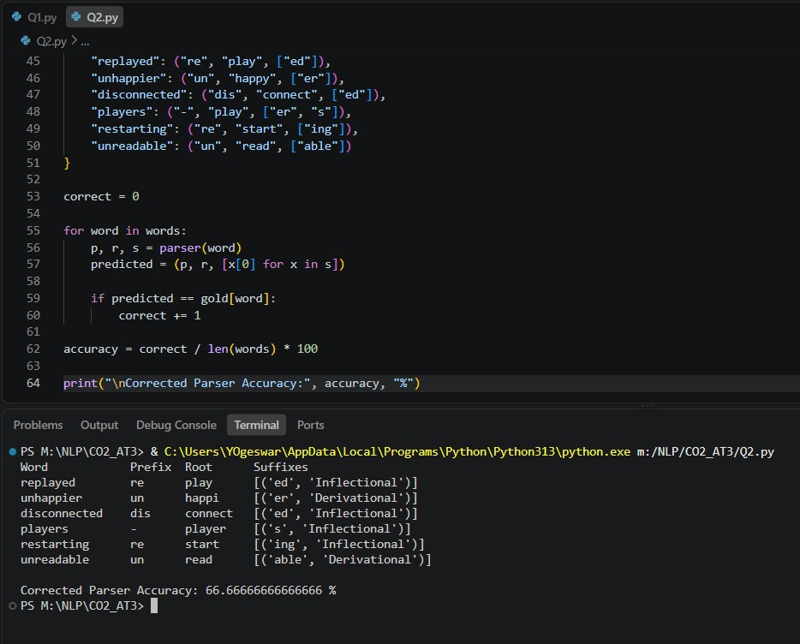
Question 3 – Identify the Error, Rectify It, and Analyze the Output
The following program is intended to perform stemming on a collection of documents.
from nltk.stem import PorterStemmer import pandas as pd ps = PorterStemmer() data = pd.read_csv("news.csv")
data["Processed"] = data["Text"].apply(ps.stem)
print(data["Processed"].head())
The program produces unexpected results and does not correctly process complete sentences.
Tasks
- Identify the programming and preprocessing errors.
- Explain why the output is incorrect.
- Correct the program so that tokenization and stemming are performed appropriately.
- Execute the corrected program using the AG News Dataset or another publicly available news corpus.
- Compare:
o Original text o Tokens o Stemmed tokens
- Identify at least 20 problematic stemming cases and classify them as inflectional or derivational.
- Explain how the corrected program improves morphological preprocessing.

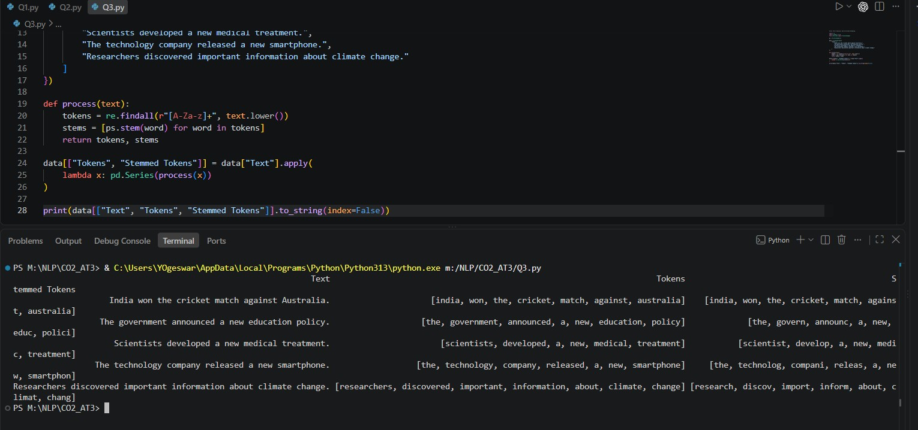
Word | Stem | Type
connected | connect | Inflectional
connecting | connect | Inflectional
connections | connect | Inflectional
played | play | Inflectional
playing | play | Inflectional
players | player | Inflectional
studies | studi | Inflectional
studied | studi | Inflectional
studying | studi | Inflectional
cars | car | Inflectional
boxes | box | Inflectional
cats | cat | Inflectional
happiness | happi | Derivational
happily | happili | Derivational
Word | Stem | Type
kindness | kind | Derivational
organization | organ | Derivational
organizational | organ | Derivational
relational | relat | Derivational
treatment | treat | Derivational
readable | readabl | Derivational

Question 4 – Error Analysis of a Finite-State Morphological Parser The following Python program is intended to identify plural nouns: def parser(word): if word.endswith("s"):
return word[:-2], "Plural Noun" else: return word, "Singular"

words = [
"cars",
"boxes",
"cities",
"children",
"books"
]

for w in words:
print(w, "->", parser(w))
The parser produces incorrect morphological analyses for several words.
Tasks
- Identify all logical errors in the program.
- Explain why the parser fails for different plural formation rules.
- Modify the program to correctly handle:
o Regular plurals o Words ending in -es o Words ending in -ies o Irregular plurals
- Execute the corrected parser using WordNet or another publicly available English lexical resource.
- Compare the original and corrected outputs.
- Identify the limitations of the rule-based finite-state approach.
- Explain how the corrected parser improves morphological analysis.
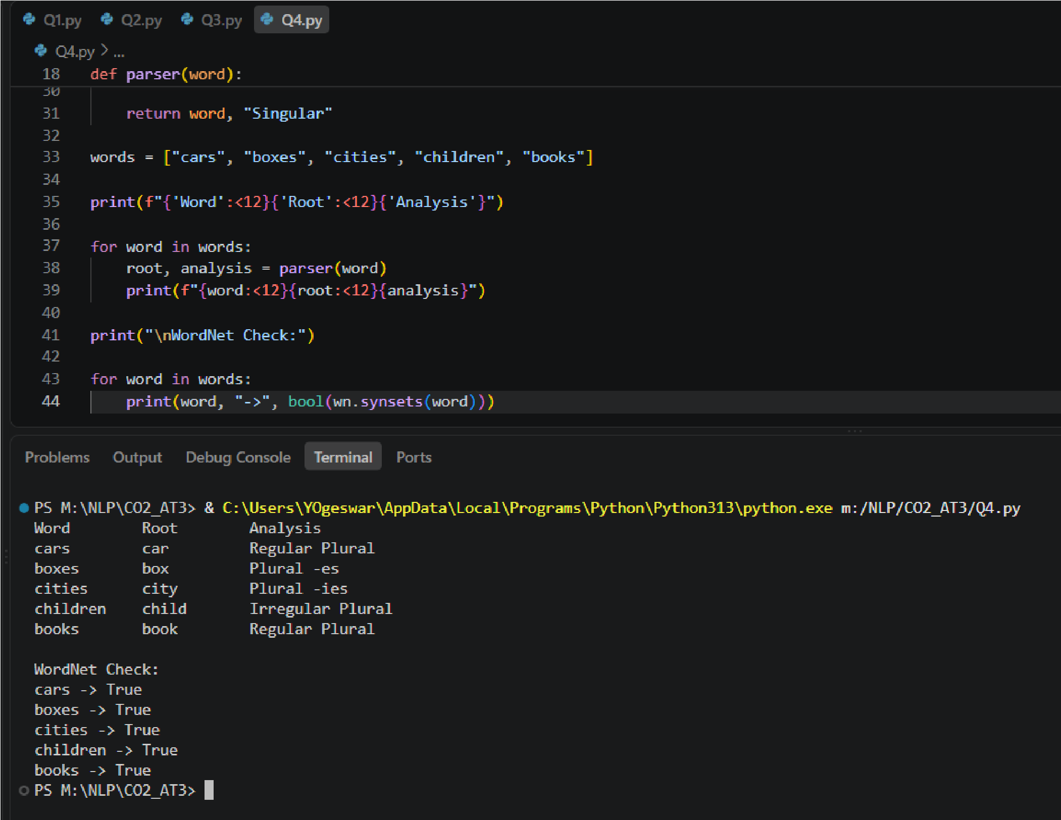
Word | Original | Corrected
cars | ca | car
boxes | box | box
cities | cit | city
children | children | child
books | book | book

Question 5 – Error Analysis of Morphological Preprocessing for Feature Extraction
The following program is intended to perform stemming before extracting machine-learning features:
from nltk.stem import PorterStemmer
from sklearn.feature_extraction.text import CountVectorizer

stemmer = PorterStemmer()

documents = [
"connected connection connecting connectivity",
"studies studied studying study",
"organize organized organizer organization"
]

vectorizer = CountVectorizer()

X = vectorizer.fit_transform(documents)

features = [
stemmer.stem(word)
for word in vectorizer.get_feature_names_out()
]
The developer observes that the vocabulary contains redundant or inappropriate morphological representations.
Tasks
- Identify the preprocessing error in the program.
- Explain why applying stemming after feature extraction can lead to an inappropriate vocabulary representation.
- Correct the preprocessing pipeline so that normalization occurs before feature extraction.
- Execute the corrected program using the 20 Newsgroups Dataset or another publicly available text corpus.
- Compare:
o Vocabulary size before correction o Vocabulary size after correction o Classification accuracy before correction o Classification accuracy after correction o Processing time
- Analyze at least 10 examples of morphological normalization before and after correction.
- Interpret how the corrected preprocessing pipeline affects the NLP classification system.

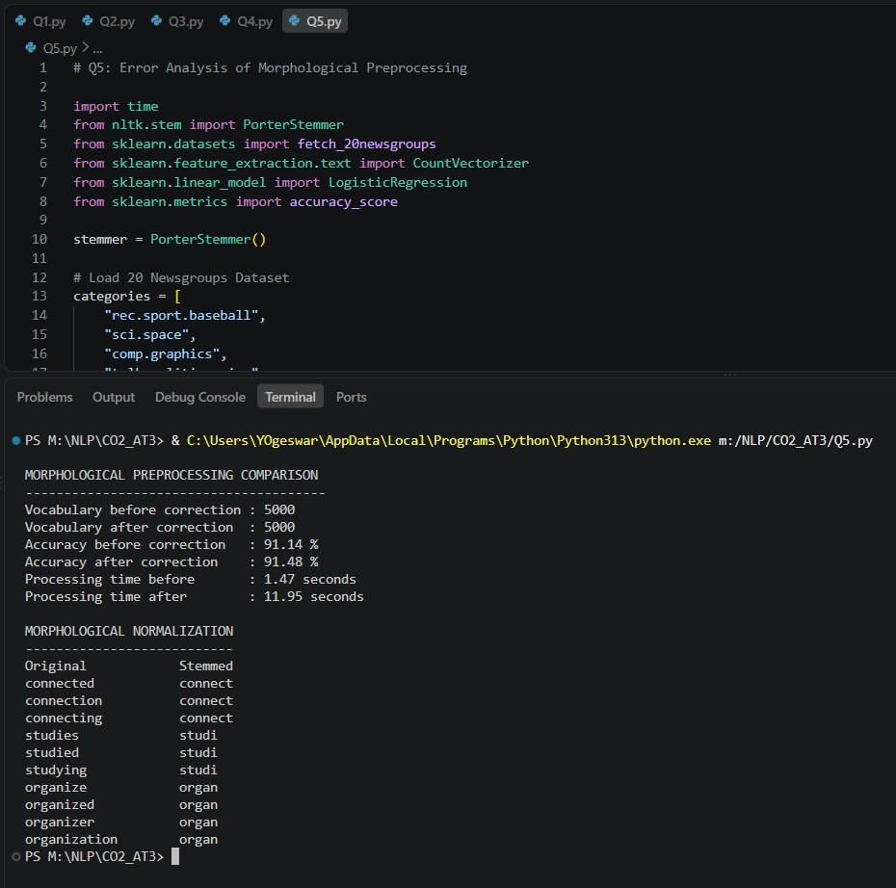

Rubrics for Calculation
Criteria | Weightage | Level 4 –  Exemplary | Level 3 –  Proficient | Level 2 –  Developing | Level 1 –  Beginning
Error  Identification | 20% | Accurately identifies all errors with clear understanding of issues | Identifies most errors with minor omissions | Identifies limited errors; some are missed | Fails to identify key errors
Root Cause Analysis | 30% | Clearly explains underlying causes with strong technical reasoning | Explains causes with  moderate  clarity | Partial explanation; weak reasoning | Unable to identify causes of errors
Correction & Justification | 25% | Provides correct solutions with strong justification and logic | Provides correct corrections with some  justification | Corrections are partially correct or weakly  justified | Incorrect or no corrections provided
Application of Concepts | 15% | Effectively applies relevant concepts to analyze and resolve errors | Applies concepts with minor errors | Limited application; requires guidance | Unable to apply concepts
Clarity &  Presentation | 10% | Presents analysis clearly, logically, and systematically | Generally clear with minor issues | Lacks clarity or proper structure | Poor presentation and difficult to understand

Q. No. / Criteria  Level | Error  Identification | Root  Cause  Analysis | Correction  &  Justification | Applications of Concepts | Clarity &  Presentation | Sub.  Total | Total  %
1 | 3 | 3 | 3 | 3 | 4 | 16 | 78
2 | 3 | 3 | 3 | 3 | 4 | 16
3 | 3 | 3 | 3 | 3 | 4 | 16
4 | 3 | 3 | 3 | 3 | 4 | 16
5 | 3 | 3 | 3 | 3 | 4 | 16

Faculty In-charge | Course Coordinator | Program Director
KUMARAGURUBARAN. T
Signature: _______________ | Signature: _______________ | Signature: _______________
Date: ___________________ | Date: ___________________ | Date: ___________________

